EXP NO 5: Create A Simple Cloud Software Application For Library Book Reservation System For Simats Library Using Any Cloud Service Provider To Demonstrate Saas.
AIM:
To Create a simple cloud software application for Library book reservation system for SIMATS library using any Cloud Service Provider to demonstrate SaaS.
PROCEDURE:
step1: Go to zoho.com.
step 2: Log into the zoho.com.
step 3: Select one application step.
step4: Enter application name as library book reservation system.
step 5: Created new application as library book reservation system.
step 6: Select one form.
step 7: The software has been created.
Output:
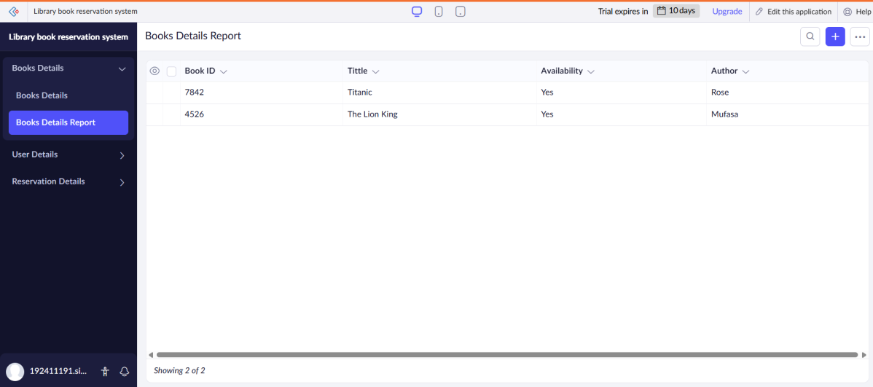
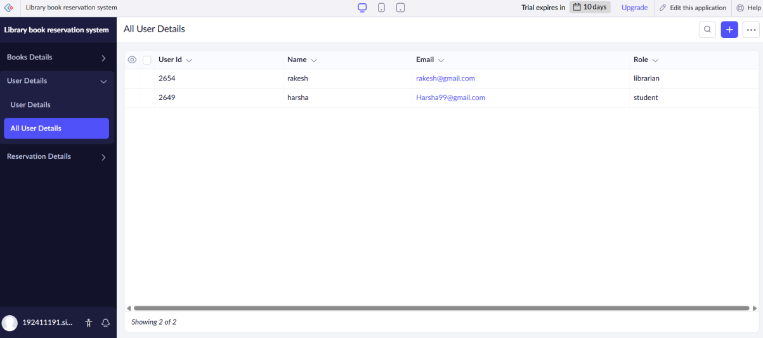
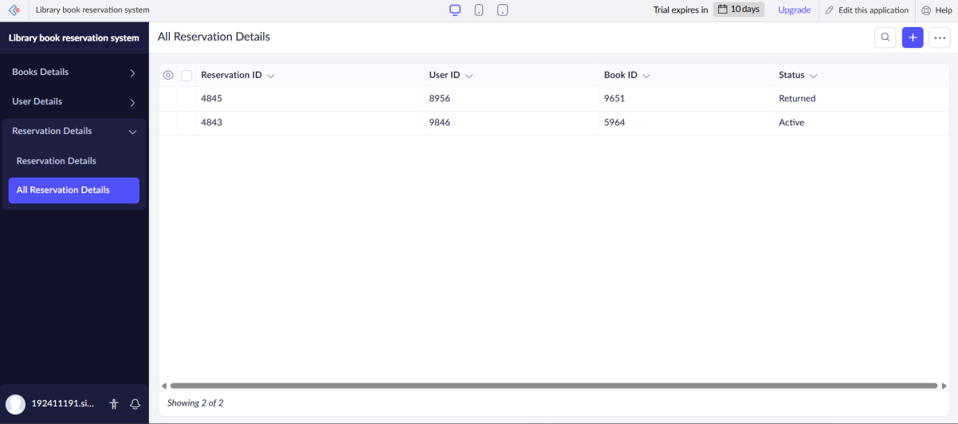
Results:
A simple cloud software application for Library book reservation system for SIMATS library using any Cloud Service Provider to demonstrate SaaS.

